CENWP-OD-B 10 July 2024

MEMORANDUM FOR THE RECORD

SUBJECT: 24BON022 MFR WA Shore UMTJ RB2 Pacific Lamprey Mortality

On the morning of 10 July 2024, Project Biologists discovered one adult Pacific Lamprey mortality in Rest Box 2 of the Washington Shore Upstream Migrant Transportation Junction LPS (WA Shore UMTJ LPS RB2). The fish was measured, scanned for PIT tags, inspected, and returned to the river.

- Species – Pacific Lamprey (Entosphenus tridentatus)
- Origin – Unknown
- Length – 65.4 cm
- Marks and tags – None
- Marks and Injuries found on carcass – Decaying.
- Cause and Time of Death – Unknown
- Future and Preventative Measures – N/A

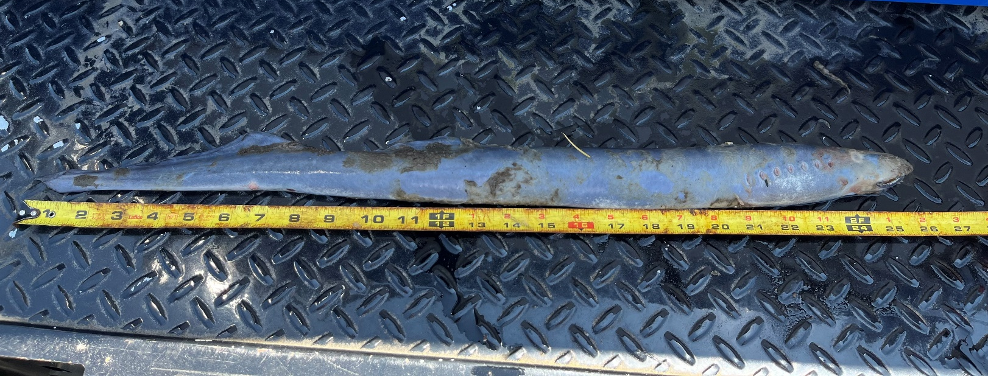

Sincerely,
Bonneville Project Fisheries

